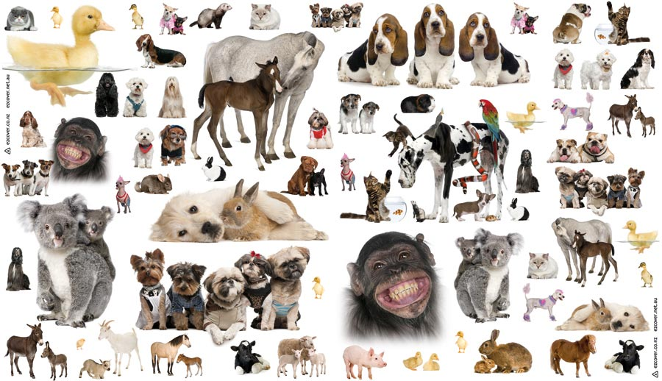

**Pets and Animals / Under the Sea**

Summer 12017

**Literacy**

Reading and writing instructions for caring for a pet

**Books –**

Dear Zoo,

Little Rabbit Foo Foo,

The Rainbow Fish,

Brown Bear, Brown Bear?

The Hungry Caterpillar

Walking through the jungle

Snail and the Whale

Peter Pan

Aaaarrggh, Spider!

Busy Pets

The Great Pet Sale

**Understanding of the World**

Visit from Waggy Tails/pet shop

Visit the school fish tank

Trip to the local park to see a fish pond

Explore different tactile/sensory materials- straw, fur, wet and dry cotton wool, shells in sand etc.

Talking about/looking at own family and friends’ pet(s)

Taking photographs of animals and pets

**Physical Development**

Making and following animal tracks

Moving like different animals

Pet/animal photo hunt

Catch inflatable fish in swimming lessons

Bury and find fish in sand

Water play- splashing and pouring into different containers

Washing hands after handling animals

Washing/caring for small world animals

**Maths**

Sorting and matching animals

Making symmetrical butterflies

1 -1 correspondence and pattern - matching tails to animals

Data handling – finding favourite animal

Filling and emptying containers with sand/water

Exploring 1 and lots of fish

Pricing animals and items in pet shop

Positional language, e.g. Where is the dog?

Comparing sizes of animals and objects

**Expressive Arts and Design**

Make animal masks

Vet/Pet shop role play

Making stripy tigers and zebras

Counting pets/animals legs, eyes, ears etc.

Listen to the sounds of the sea and play instruments to make sea sounds

Painting shells

Make cotton wool rabbits, furry animals and scaly fish

Printing with animal/fish sponges and shapes

Make sea creature instruments

Make sensory jelly fish, ocean bottles, and ocean sensory pouches

Making animals for pet shop e.g. fish and snakes

Responding to the feel and smell of different animals

**Songs:** The carnival of the animals, Under the sea, Five little ducks, Five little speckled frogs, The animals went in 2 by 2, Old MacDonald, See the sleeping bunnies. I Have a Pet; How Much is that Doggy in the Window?

**Personal, Social and Emotional Development**

Learning how to be gentle with animals

Role play pet shops, dog parlours, farms etc.

Role play scuba divers and under the sea explorer

Learning what animals need to be happy and healthy

Taking turns in role play

**Communication and Language**

Learning words, symbol and signs for animals

Listen to and discriminate animal sounds

Imitating animal sounds

Choosing sensory sea activities

Identifying favourite animals

Describing animals

Role play