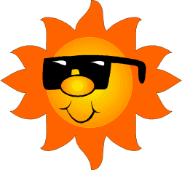
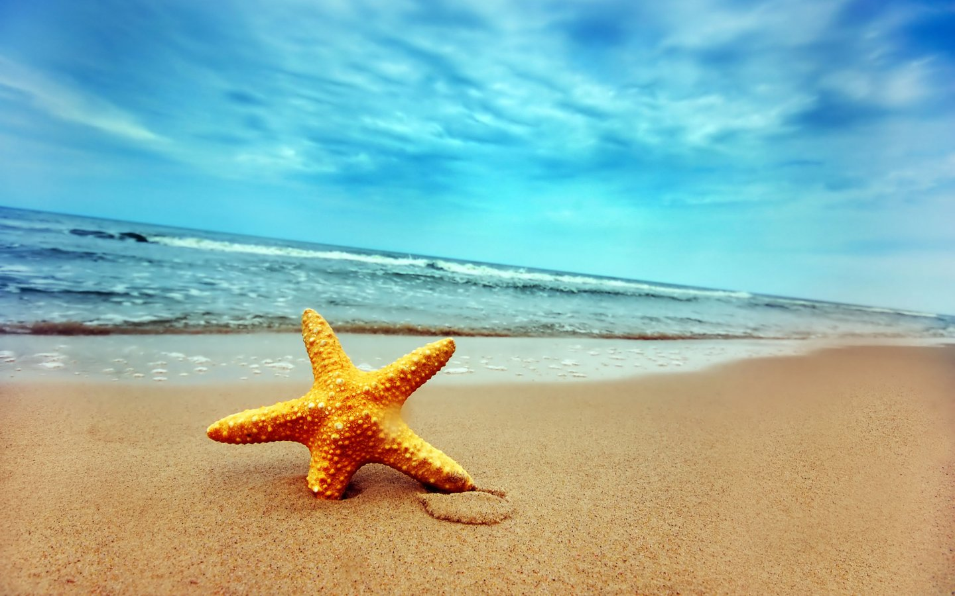

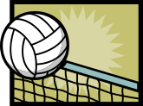
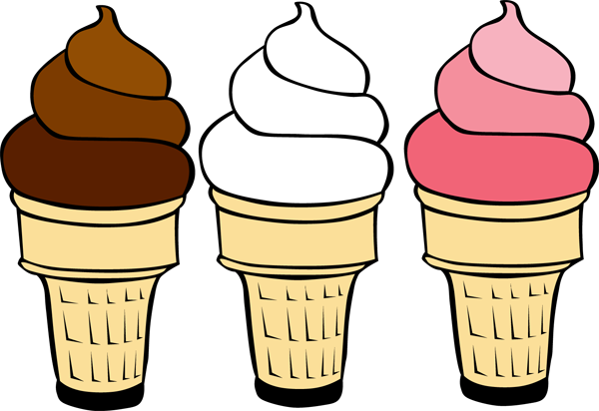

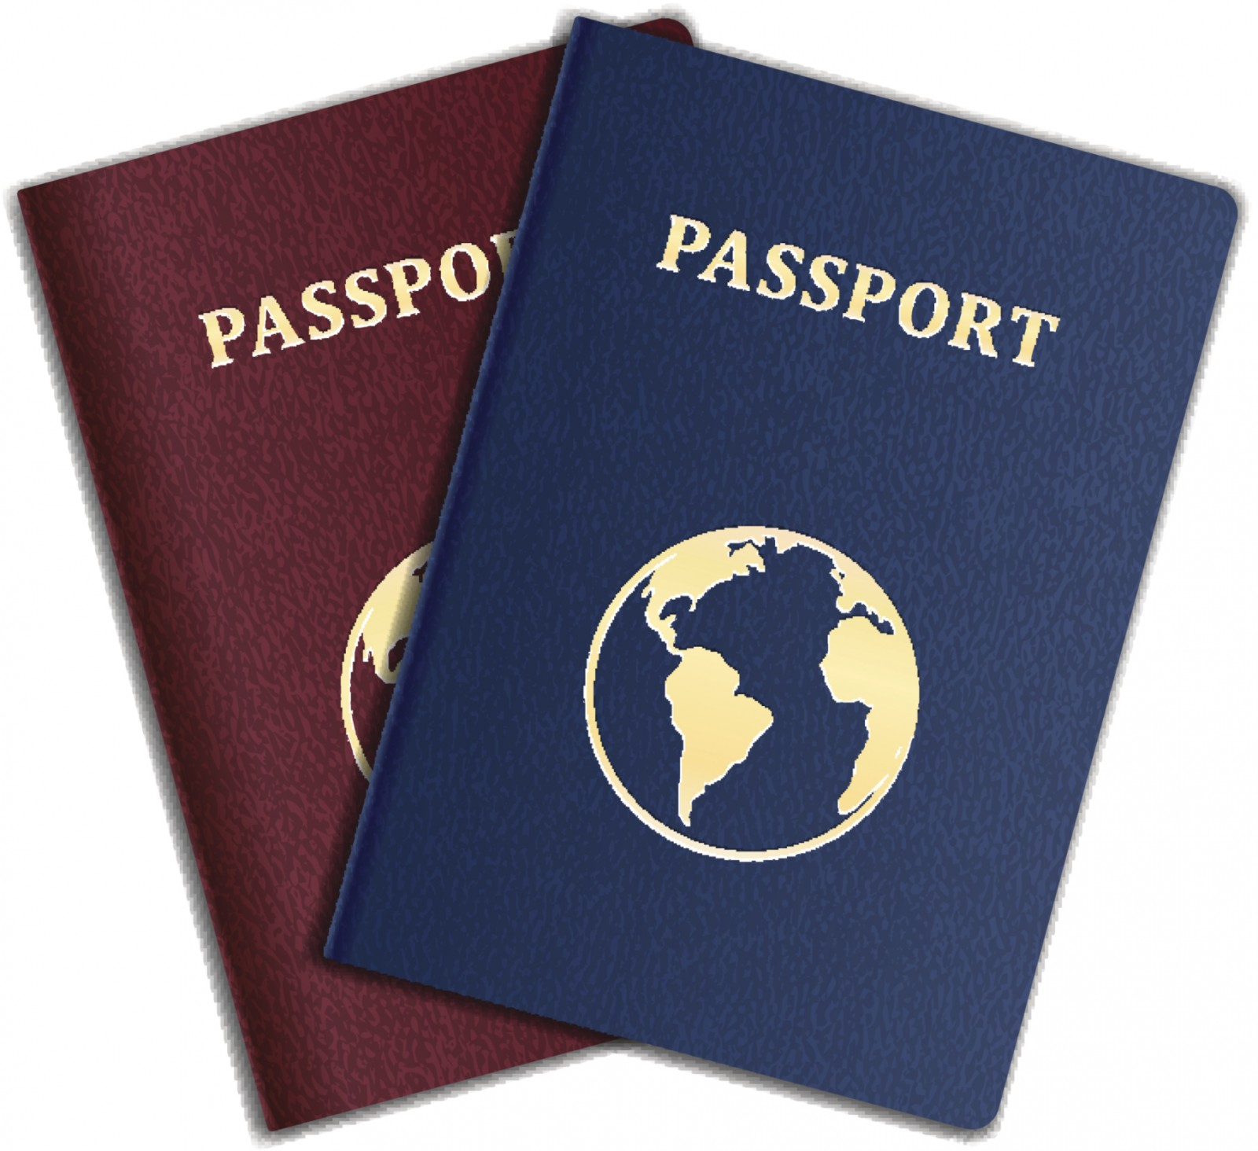
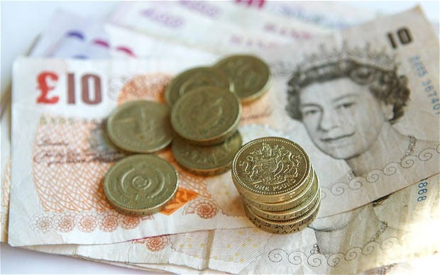
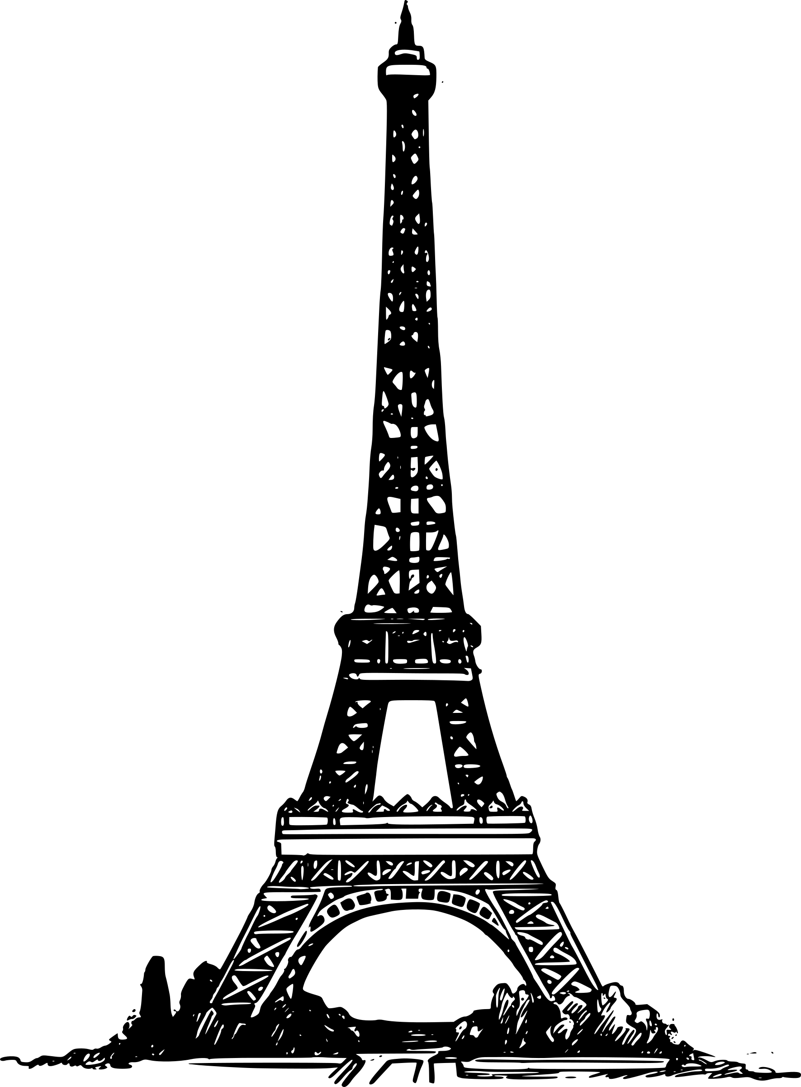
Understanding of the world
Science
Everyday materials
Investigating different materials. What are the landmarks made of?
Testing materials – which is the strongest? Which is the best to build with?
Beach – sand investigations.
Cars and their materials (Le mans)
Squashing grapes using different parts of the body.
What to pack for a holiday. Investigating clothes.
States of matter
Water investigations
Melting/freezing – What happens to ice-cream in summer?
Making things using wet and dry sand.
Investigating warm/cool clothes.
Seasonal Changes
Observe changes across the 4 seasons
Observe and describe weather associated with the seasons and how day length varies.
Geography
Maps. Where are different countries? Where is land/. Where is ocean? Routes of different races. Where is Wimbledon?
Comparing two countries. What is different between England and France?
Comparing different holidays –seaside/countryside/town
Modes of transport – Eurostar, driving, ferry, flying, swimming.
Looking at road/travel signs.
History:
Seaside holidays in the past.
R.E
Religious festivals – public holidays.
Communication
Songs – Frere Jaques/We’re all going on a summer holiday
Mime, gestures and signing
Learning new words in French (numbers, colours, hello, goodbye e.c.t)
Learning new vocabulary and key topic words.
Responding to routines in class.
Asking questions about new topic.
Choice making between objects and areas.
Play opportunities using outside areas.
Intensive interaction .

Functional Skills
Reading
Traditional French stories (Hunchback of Notre Dame, tom thumb, Cinderella, sleeping beauty, Beauty and the Beast, puss in boots)
Bear hunt – finding French things on our hunt.
The lighthouse keeper
The train ride
Recognising words and sounds in key vocabulary.
Daily phonics (Jolly Phonics)
Phonics differentiated groups (x1 a week letters
and sounds)

Writing
Constructing sentences using symbols and pictures.
Writing letters to French children.
Postcards
Travel brochures
Creating passports
Writing a holiday shopping list.
Writing recounts of trips and visits they have had.

Maths
Counting and number work focusing on holiday objects and items.
Money and change – buying things for a holiday/French shop
Building the Eiffel tower.
Creating shape pictures and new sculptures.
Data handling (where appropriate) –
Collecting data about favourite holiday place.
Creating graphs and interpreting them using
the data.
Water/sand play – working on filling
emptying/capacity.
Measuring – Length and distance

Creativity:
Art
Creating flags
Artists: Vincent Van Gough, Monet Matis
Summer scene painting
DT
Sculptures
Designing and making clothes for a fashion show.
Creating own ice lollies.
Cooking
Pancakes
Fruit salads
Food for a picnic
Physical Development
Dancing to French Music
Sports: Boules/botcha, Croquet, Volleyball, Car racing, bike racing, Ascot (Horse racing), Tennis
Physical development- movement through dance & outdoor games
OT skills- personalised gross motor and fine motor skills, Physio skills and targets
Sports day events.
We’re all going on a Summer holiday –Europe/Summer
Personal, Social and emotional development:
Living in the wider world:
Understanding and exploring other cultures and traditions e.g different European countries.
Sharing a picnic with friends.
Learning independence skills – Making own food, asking questions,
Helping in the environment around us – helping others with gardening and growing ec.t.
Learning about the importance of money and where is comes from. How to budget and spend money (Basic sense of exchanging money for goods in some classes)
Develop sharing of summer toys.

