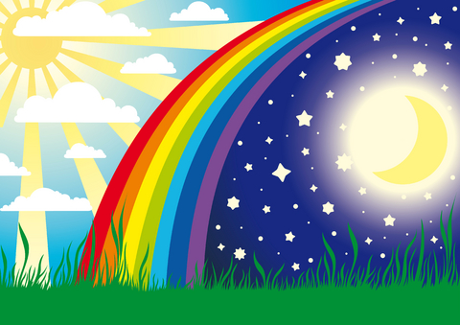

**Maths**

Morning/night time routines

Rocket role play-countdowns 5,4,3,2,1 building anticipation

Putting planets in order on a mobile/ story

2D/3D shapes--sphere/circle

Different ways the moon appears in the sky

Exploration of foil-long lengths, scrunch into balls

Hide torches and lights under materials and in boxes.

As part of morning routines, mix breakfast cereals with milk (see also UW and PSED)

Tell the time—at significant times—e.g. play time, dinner time, home time. Wind up clocks and timers and listen for alarm

Play games: e.g. What’s the time Mr Wolf? <http://www.babytv.com/dreams.aspx>

‘This is the way we brush our hair, brush our teeth, wash our face’

Daily routines song:

<https://www.youtube.com/watch?v=eUXkj6j6Ezw>

**Understanding of the World**

Look at shadows using torches and during outside play

Explore bedtime objects-blanket, teddy, pyjamas, teeth cleaning etc

Explore different lights, fluorescent, shiny materials

Using switches to turn lights on and off/understand how batteries make a torch or lights work.

Use a light box to see items clearly

Explore different torches and light toys and shine on different materials

Signal start of festivals e.g. Christmas by turning on the lights in each class

Animals that are awake at night—e.g. explore different materials for Owl Babies story-twigs, feathers, leaves

Road safety—wear bright clothes/fluorescent items to be seen in the dark Shine torch on dark/light clothes.

Experiment with torch to make shadows

Festivals/celebrations of light include: Diwali, Bonfire Night, Christmas

**Literacy**

Mark making in ‘galaxy’ sand, glittery gloop

Mark make or track with florescent/ UV materials in the dark

Make books e.g. my day at school

Use writing skills to label and caption pictures; write invitations, say thank you etc.

Use phonetical knowledge to read words and captions

Read/share book with a friend/adult

**Some fiction**

Peace at Last Owl Babies Can’t you sleep little bear?

How to Catch a Star The Cave The Dark

Also **non fiction** books about the moon, stars, the sun etc.

The Earth is like a roundabout by Claire Llewellyn;

Sensory story based on the Moon landing

**Physical Development**

Find motivating/light up toys hidden under light and dark materials

Co-operate with hand/face washing, cleaning teeth, brushing hair

Make toast and smoothies for breakfast (using senses to explore different toppings/ingredients)

Explore dark and light environments such as dens, tunnels, tents etc.

Story Massage—connecting physical/and story telling

Dress up for parties, performances and celebrations

**Personal, Social and Emotional Development**

Experience daytime and night time routines-going to bed, waking up in the morning

Participate in sharing role plays e.g. make breakfast or drinks for everyone

Participate in caring role play bathing babies and teddies and bedtime routines

Experiencing quiet times with calming music/lullabies

Work with others during art/science/music activities

**Expressive Arts and Design**

Paint large moons e.g. with glue and shaving foam

Make night time pictures using blue, black, purple paint and stars

Add white/black to colours to make them lighter or darker

Listen to the dawn chorus and morning bird sounds and night owl sounds

Make owls

<http://happyhooligans.ca/adorable-owls/>

Listen to lullabies

Twinkle, Twinkle, Little Star

Make/decorate candle holders and night lights

Classical music: Holst *The Planets*; Richard Strauss *Thus Spake Zarathusra*

Make simple shadow puppets or watch shadow shapes through a white sheet.

**LOWER SCHOOL**

**Night and Day/Space**

Autumn 2 2019

**Communication and Language**

Using a Big Mack or joining in with parts of a story

Making choices between preferred materials, experiences

Copy signs and vocalise key words from sensory stories and familiar songs

Copy key signs such as night, day, light, star

Anticipate what is next in the rhyme “Dark, dark forest…”

Some key words: dark, light, on/off, time words e.g morning, night. Space words e.g. planet, sun, moon, describing words: hot, cold, far, near