Activities to keep your children active

Fine Motor coordination development

Indoor Fine motor skills Challenge cards

Try these activities with your child to help develop their fine motor skills.
Twinkl:
https://content.twinkl.co.uk/resource/f5/6e/t-a-064-indoor-fine-motor-skills-challenge-cards-_ver_1.pdf?__token__=exp=1584615226~acl=%2Fresource%2Ff5%2F6e

Using pegs

Equipment | How to play
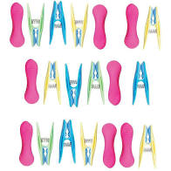  Pegs  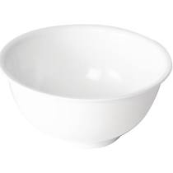  Saucepan / mixing bowl | See how many pegs you can attach to the bowl in a timed period.  See how many pegs you can take off the side of the bowl in a timed period.

Tong pick up

Equipment | How to play
Pair of tongs, bowl ,rolled up socks  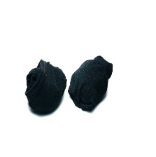  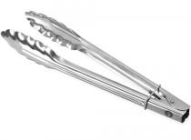 | Pick up different size objects (light in weight) and drop into bowl  See how many items you can drop into the bowl in a timed period.

Pass the egg

Equipment | How to play
Empty egg carton x 2  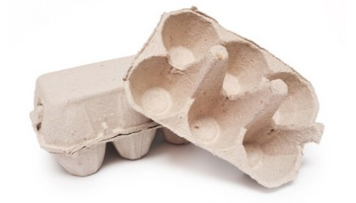  Hard boiled eggs / tomatoes/ ping pong balls | Transfer eggs / tomatoes/ ping pong balls from one container to the other.  Use a timer to see how quickly you can do it.  Try it with your non dominant hand too if you are able to.

Tube target

Equipment | How to play
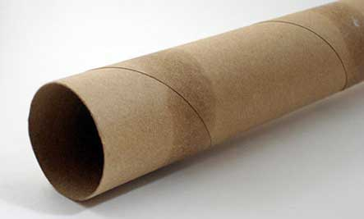  Kitchen roll tube  Bowl  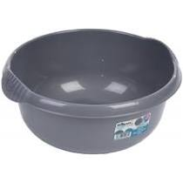  Table tennis balls  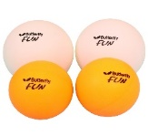 | Pick up the table tennis ball or small object ( that can fit in a kitchen roll tube)  Aim the tube at the bowl and release ball/ object down the tube into the bowl for a goal  Count how many you can get out of 5.  Try your non dominant hand too

