Play Activities – Textured - Feeling
Foil
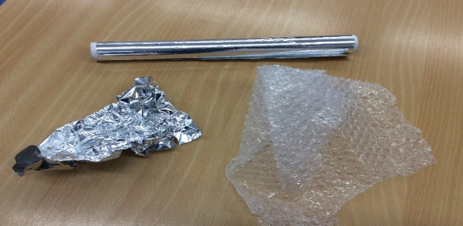
- Foil – scrunch up the foil near the child so they can hear it, help them pick up the foil and scrunch it in their hand.
- Place a torch or light up hand toy over or under the foil to see the different patterns.
Bubble wrap
- Bubble wrap – scrunch the wrap in their hand, pop the bubble wrap near the child so that they can hear the pop.
- If you have a large piece of wrap lay it on the floor and wheel the child across it. Hear it pop – make up a story or song about the leaves crunching or fireworks crackling.
Brushes
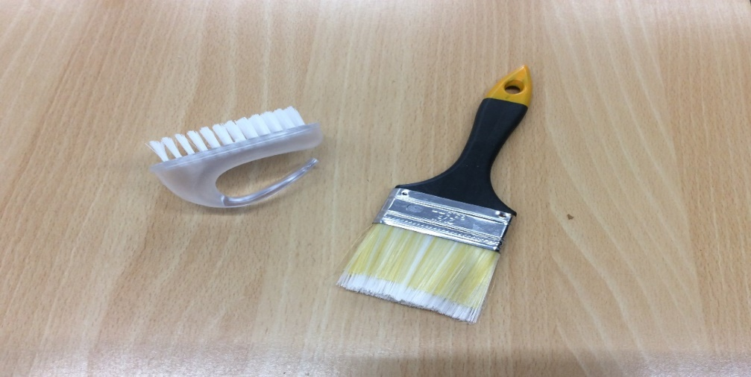

- Brushes – Hard and soft brushes, gently stroke across the hand and body fast and slow movements to music.

- You could stop brushing and wait for the child to respond vocally or physically letting you know to continue, repeat the activity. (pause and response)

Different textured materials

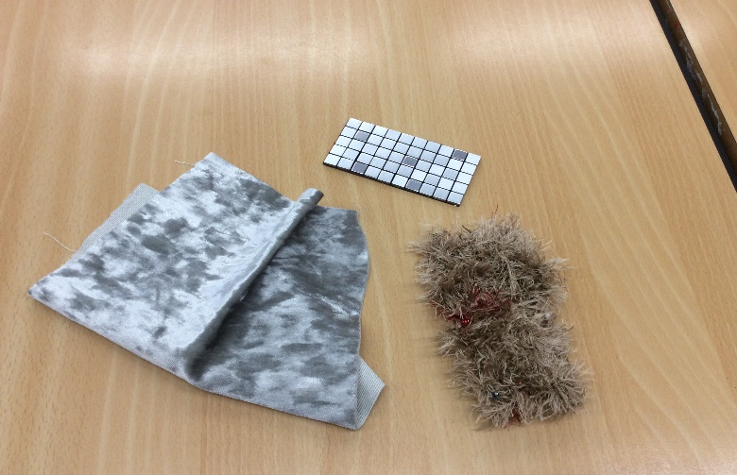

- Different textured materials – gently dab the materials on the body, gently stroke the materials across the body and assist them to feel the materials in their hands by scrunching it or rubbing it with their fingers.

Sponges and bath scrunchie

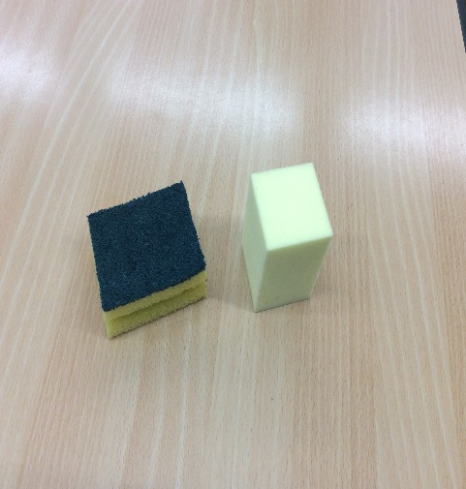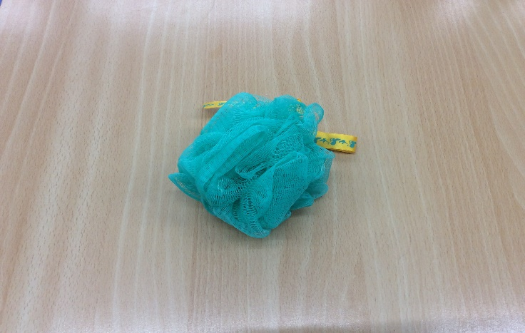
- Sponges and bath scrunchie – gently pat or dab the sponges on the body and squeeze them in their hands.

- You could wet the items and get the child to squeeze the water out of the sponge into a bowl.

- Another suggestion is to use the sponges to mark make and create patterns on paper using the sponges dabbed into paint.
Water and foam
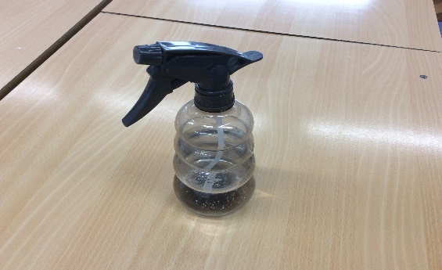
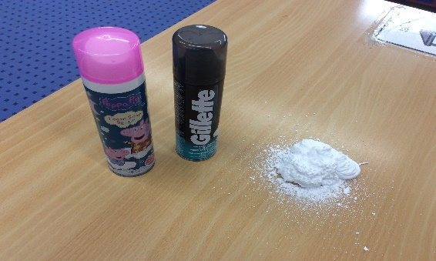

- Water spray and foam – Place some foam onto the table top or tray, let them move their hands freely through the foam.
- You could put some on black paper with either a dab of paint or food colouring for them to mark make or create patterns.

- The water spray could be used as part of a weather song or story – (you tube dream England.com - the sun comes up) water as rain, foam as snow clapped between hands, something yellow as the sun and something white for the clouds.

Umbrella
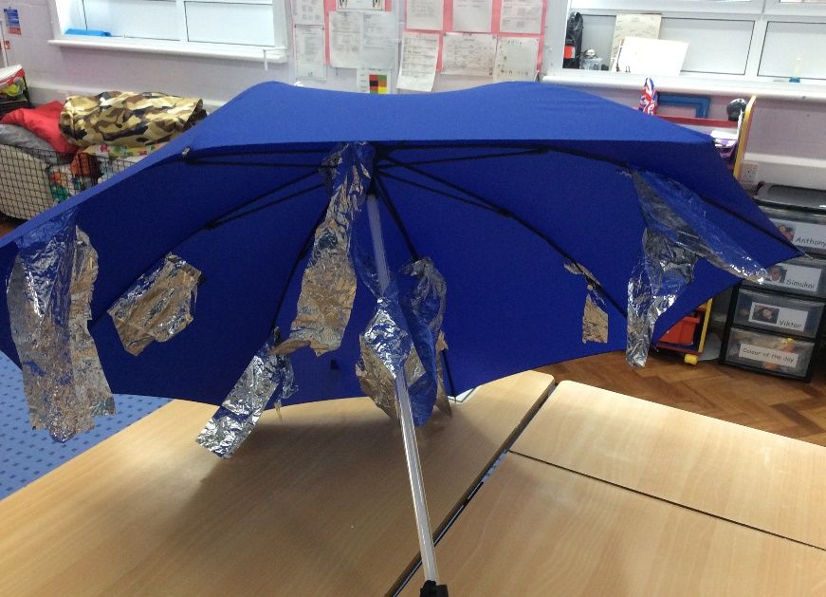
- Umbrella – You could hang pieces of foil on the inside of an umbrella, ribbon, beads or wool would also be very good and will encourage the child to reach out to touch it.
- Another suggestion is to spray water onto it, so that the child can hear the pitter patter sound and see it drop of the ends of the umbrella.
- With the lights off shine a torch or light up hand toy onto umbrella moving it around to make patterns.

