Activities to keep your children active at home

Games for hand / eye coordination

Balloon Volleyball
Equipment | How to play
Balloon  String / rope – to create a net | Try to keep the balloon off the floor – see how many times with a partner you keep the balloon in the air  Try to ground the balloon on the floor on the floor of your oppositions side of the net

Target practice

Equipment | How to play
Washing basket  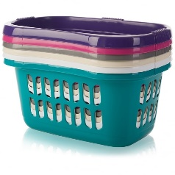  Rolled up socks | Aim at the basket and see how many rolled up pairs of socks you can get in the basket  Increase the distance of the basket to make more difficult

Bowling

Equipment | How to play
Empty coke or lemonade bottles  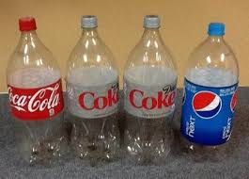 | Set up a line of empty coke/lemonade bottles like ten pin bowling.  Roll / throw a ball OR rolled up socks at the line of bottles  See how many you can get down.

Equipment | How to play
Empty cereal boxes, tea bag boxes and any other boxes  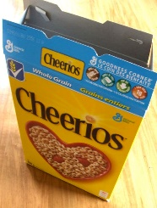 | Stack the boxes to make a tower  Knock them over by rolling a ball or rolled up socks

Tin can alley

Equipment | How to play
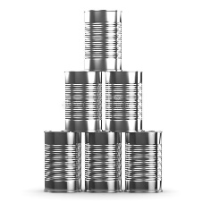  Empty tin cans | Stack the cans  Knock them over by rolling a ball or rolled up socks

Gross Motor activities

Equipment | How to play
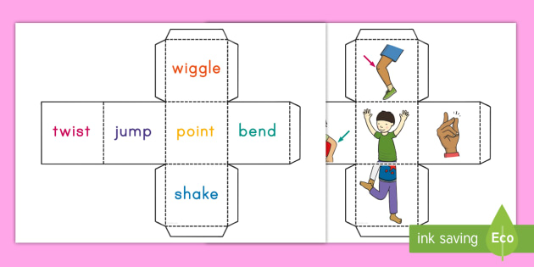  Resource sheet  2 dice | Make the 2 dice using the printed resource.  Take turns rolling the dice  Do the movement, using the selected body part.  You can change the body part or action dependent on your child’s needs

Twinkl
https://content.twinkl.co.uk/resource/1e/de/us-a-195-roll-and-move-gross-motor-activity-english_ver_1.pdf?__token__=exp=1584616700~acl=%2Fresource%2F1e%2Fde%2Fus-a-195-roll-and-move-gross-motor-activity-english_ver_1.pdf%2A~hmac=6f2d8b60e6764c94656df1e06e7d355ab5d245cbd8e35b6b847f25a8c89580c4

Wii Just Dance on YOU TUBE

Equipment | How to play
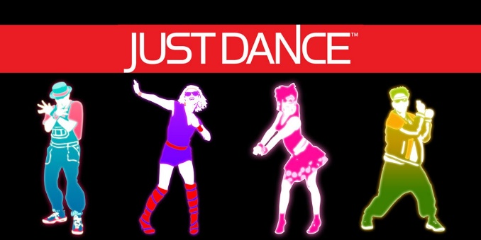  You Tube – Just dance  Suggested songs:  Waka Waka -Shakira  Cotton Eye Joe - Rednex  Happy – Pharrell Williams  Can’t stop the feeling – Justin Timberlake  Dancing Queen – Abba  A little less conversation – Elvis  Eye of the Tiger – Survivor | Follow the dance movements on the screen.  Have fun. It’s a great way to work out

Joe Wicks PE lessons ( Mon – Frid)

Equipment | How to play
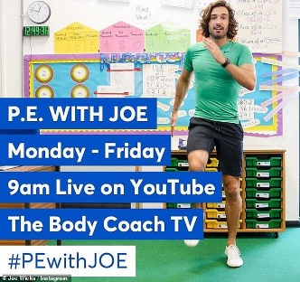 | If you are able to try to join with some of the activities Joe Wicks will be leading on his, You Tube Channel.  Its free!!

GoNoodle

Equipment | How to play
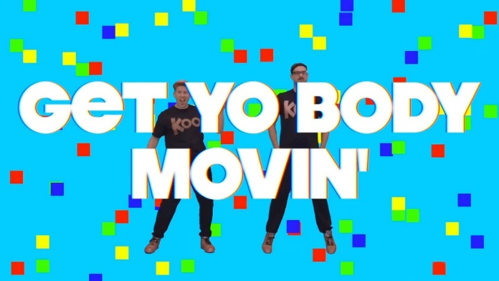 | Go to You tube and type in GoNoodle “Get yo body movin”  It’s a fun action song for all to join in with

Exercise, Rhyme and freeze- Jack Hartman

Equipment | How to play
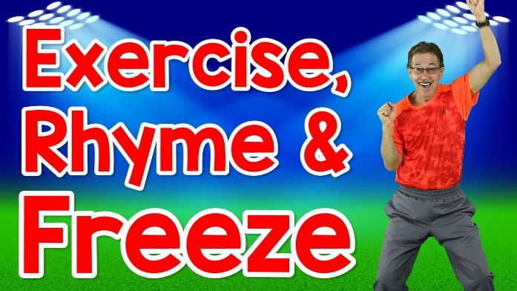 | Go to You tube and type in  “Exercise, Rhyme and freeze” Jack Hartman  This is a fun action song that also helps learn rhyming words.

