Physical and Sensory – Pre-formal Curriculum
Physical and Sensory

Physical and Sensory
Pre-Formal Curriculum
Intent - What are we trying to achieve through our curriculum?
The Pre-Formal Pathway curriculum for Physical and Sensory recognises that the physical and sensory well-being of the learner with PMLD is of paramount importance and may therefore take up a large percentage of curriculum time.
Learners following the Pre-Formal Pathway curriculum for Physical and Sensory:
- Learn holistically, following a curriculum that is interconnected.
- Have access to personalised learning, using specialised teaching approaches.
- Receive a curriculum that is adapted to reflect their interests and motivations to engage them.
- Will receive support from staff who have had access to appropriate training and equipment.
- Have their therapeutic and medical needs met e.g. positional changes are made safely.
- Experience warm, communicative and appropriate touch and physical contact as part of the curriculum.
- Need different levels of sensory stimulation and have information on their sensory preferences and avoidances recorded and monitored.
- Have their access to physical and sensory activities maximised through support from Physiotherapy and Occupational Therapy

Aims;

My Physical Wellbeing:

Posture
- We aim to work closely with learners’ physiotherapists to understand their postural needs,
- We aim to give learners the opportunities to have regular positional changes throughout the day,
- We aim to be sympathetic to the experiences, feelings and emotions of the learner, follow guidance from therapists closely and try to make positional changes and use of equipment like standing frames as fun as possible,
- We aim to ensure that the body postures of learners with gross motor disabilities remain symmetric,
- We aim to enable learners who require weight bearing activities sufficient opportunities to do this.

Swimming
- We aim to give learners the opportunity to experience the movements that their bodies can make in water, developing control of their bodies in the water. We aim to use the water to promote physio exercises, changes in body positioning, posture, motor skills and additional sensory stimulation.

Rebound Therapy
- We aim to use Rebound therapy to develop and promote posture, motor skills, body awareness, balance, co-ordination and communication by creating a multi-sensory environment,

My Body Awareness:

HandiPac
- We aim to use HandiPac (use of hands) to develop learner’s communication and body awareness through combining their sense of touch and music through social interaction,
- We aim to deliver the planned session in an emotionally safe environment, clear of other sensory interferences.
- We aim to respect learners personal space and request consent prior to any HandiPac experience by recognising their personalised communication methods

Tac Pac
- We aim to use Tac Pac (Use of objects and hands) to develop learner’s communication and body awareness through combining their sense of touch and music through social interaction,
- We aim to deliver the planned session in an emotionally safe environment, clear of other sensory interferences.
- We aim to respect learners personal space and request consent prior to any Tac Pac experience by recognising their personalised communication methods

My Play and Leisure:

Eye / hand coordination and fine motor control
- We aim to ensure that eye / hand coordination is not taught in isolation but worked on through activities that are motivating to the individual e.g. exploring art materials, accessing “individualised sensory environments”,
- We aim to ensure fine motor control is not taught in isolation, but worked on through activities that are engaging and motivating to the learner e.g. manipulating objects through rich sensory experiences

Massage
- We aim to respect learners personal space and request consent prior to any massage experience by recognising their personalised communication methods,
- We aim to support learners with a range of massage experiences to teach whole body awareness, proprioception, loosen muscles and ease stiffness – this may include Tac-Pac, Handi-Pac, Story Massage and Art to Body,
- We aim to be sensitive to the communications of the learner during the massage, giving learners the maximum opportunity to concentrate on what is happening to their bodies in sessions, reducing the potential for sensory confusion.

Yoga
- We aim to respect learners personal space and request consent prior to any Yoga experience by recognising their personalised communication methods

My Creative movement:

Movement to Music
- We aim to adopt the principle of “doing with” rather than “doing to” during movement sessions. We recognise that there is a risk staff members take control and are in charge of the movement e.g. during a wheelchair dance session. With this in mind we aim to be being responsive and sympathetic to the learner’s feelings and emotions and monitoring how they are physically reacting to the experience, therefore creating a movement dialogue,
- We aim to explore the variety of ways individuals can respond to e.g. learners in wheelchairs may respond to rhythmic music when out of their chairs on a resonance board.

Art to body
- We aim to use Art to Body (Use of objects, hands and art resources such as paint, foam etc.) to develop learner’s communication and body awareness through combining their sense of touch and music through social interaction,
- We aim to deliver the planned session in an emotionally safe environment, clear of other sensory interferences.
- We aim to respect learners personal space and request consent prior to any Art to Body experience by recognising their personalised communication methods
- We aim to gain parental consent for the use of paints, edible paints, foam etc. to avoid reactions to allergies

My Sensory Awareness:

Sensory Integration
- We aim to provide appropriate sensory integration techniques and opportunities for learners with a sensory processing disorder.
- We aim to work closely with learners and OT’s to understand and deliver sensory diets and programmes.

Multi-sensory Environments
- We aim to provide appropriate, planned activities in dedicated multi-sensory environments where the amount of sensory stimulation can be controlled e.g. visual tracking work, noticing stimuli and as a base for delivering some activities for working on and with senses.
- We aim to use ‘little rooms’ or ‘Be-Active Boxes’ to provide small scale environments.

Activities for working on and with senses
- We aim to provide appropriate sensory stories that offer learners opportunities for repetition within the story and of the story – the same story should be repeated for at least half a term. Learners should participate as much as possible with opportunities to explore the props and have an interactive relationship with them. Staff should act as ‘secondary’ storytellers – repeating the lines on a one-to one basis.
- We aim to provide learners with Individualised Sensory Environments e.g. tray of objects that a learner can experience through their senses e.g. touch, scent, taste. This is used as a means of discovering the learners’ sensory preferences
- We aim to provide our learners with opportunities to take part in sensory cookery to access a variety of sensory exploration and experiences. This is process based teaching and learning rather than product (skills) based teaching and learning.
- We aim to provide learners with opportunities to take part in sensory and interactive art to access a variety of sensory exploration and experiences.

Sensory rooms
- We aim to provide appropriate physical and sensory activities in the sensory rooms according to the children’s needs. These activities include opportunities to explore and use their senses, to explore and use sensory materials and to use and develop their physical skills.
- We aim to utilise our sensory rooms in the best possible ways and some of the activities include TACPAC sessions, massage, sensory stories and carrying out the children’s physio and VI programs.
My Outdoor School Learning:

Outdoor Learning
- We aim to plan activities in outdoor multi-sensory environments that give opportunities to develop eye / hand coordination and fine motor control and where appropriate gross motor activities,
- We aim use to plan activities outdoors that can provide vestibular and proprioception stimulation through the use of accessible bikes and sensory playground equipment,

Curriculum Design;
All pre-formal learners throughout the school will focus on the EYFS Prime areas of development:
• Communication and Language,
• Personal, Social and Emotional Development
• Physical Development.
A broad and balanced curriculum is achieved through accessing content from the full pre-formal curriculum including Physical and Sensory Wellbeing, and also through the School Department cycles of termly classroom cross-curricular topics.
Implementation - How is our curriculum being delivered?
Curriculum Delivery
Like other Pre-Formal curriculum areas, much of the Physical and Sensory Wellbeing Pre-Formal curriculum is delivered holistically rather than as a series of separate skills and subject areas. However, all PMLD learners receive a dedicated PE lesson each week and have access to a dedicated multi-sensory room at least once a week. There are further opportunities to access these rooms to reflect Learners sensory needs. Learners receive a swimming lesson once a fortnight.

Assessment Framework Level | Curriculum Content  What the learner is learning | What the adult working with the learner does | Enabling Responsive Environment  Learning Opportunities / What is provided | Cross- Curricula Topic Cycle Links/ Opportunities during the School Year
Encounter (P1i)  Pupils encounter activities and experiences. | Pupils are supported to encounter activities and experiences and to develop changes in behaviour that are not reflex responses. | Try an on/off pattern with a stimulus.  When no response is observed, make the stimulus more obvious.  - Start with a very obvious stimulus on or close to the body  - Present vibration, e.g. massager or vibrating cushion.  - Rock the learner gently  - Play music or a familiar song; musical instruments  - Present a torch reflected on a shiny surface. If there’s no response, try moving it slightly - In a darkened corner, present a repeated pattern of ‘stimulus: no-stimulus’, i.e. light: no light.  - In PE Use a black light up umbrella and shine a sensory coloured torch onto the umbrella. Move the torch and the turn off to await a response.  - In PE Use a quoosh ball, silver bowl and sensory coloured torch. Shine the torch in the bowl to cover ball. Turn torch off to await response, repeat.  - To allow and provide opportunities to explore sensory items with and on different body parts to different music, encouraging awareness of their body. e.g. pom poms, feathers  - To offer hand under hand movement to music and support to hold material.  - To provide a range of sensory experiences to mark make e.g. Textured objects in Art to Body  - In swimming look for anticipation and responses to additional sensory stimulation in the form of lights and music  Useful resources:  Interactive PE with music  Sensory Art with Elaine  http://www.st-gilesschool.co.uk/home-learning-resources/ | Intensive Interaction  Musical Interaction  Communication Aids E.g. Big Mack  Cues e.g. Touch Cues, Sound Cues, Smell Cues, Objects of Reference,  Language Activities E.g. Call and Response, Sensory Stories  Individualised Sensory Environment (ISE)  Sensory Cooking  Sensory Exploration – Tac Pac  Art to Body  Sensory Integration  Massage/Story Massage  Yoga  Rebound Therapy  Mindfulness  Sensory Dance Massage  What’s in the box  Write Dance  Swimming | Out in the community e.g. park, farm, zoo, garden centres, shops, theatres, cinemas, London attractions, museums  Links with other schools/colleges  Wow events  Assemblies  Outside organisations such as Waggy tails, police, fire and ambulance services, Drama groups, Croydon Mozart Players, dance /movement workshops,  Animal handlers, Colourscape, Dome experience.  Charity events e.g. Sports Relief, Jeans for Genes Day
Awareness (P1ii)  Pupils show emerging awareness of activities and experiences. | Develop learner’s emerging awareness of activities and experiences.  Continue to look for any changes in behaviour which are not reflex responses.  Work towards developing learner’s memory for previously presented stimulus. | Present an obvious stimulus to the learner in a similar way, taking care not to startle.  - If the learner responds best to auditory stimuli, try talking and singing close-in to the learner, with pauses for close observation of possible responses.  - Hold the learner and talk or sing, leaving pauses for any response.  - Try a vibrating cushion, resonance board, or a water bed.  - Present different textures, such as warm sand, with which learners can engage.  - Try using musical instruments, tapes, musical toys.  - Use peep-bo, puppets, pop-up toys.  Increase the range, complexity and variety of stimuli used in Awareness (P1i) above  - Use warm up songs in PE which have moments of stillness and movement. Use the words “stop” and “go “to look at changes in behaviour when the music stops.  e.g. Party Freeze Game. | Intensive Interaction  Musical Interaction  Communication Aids E.g. Big Mack  Cues e.g. Touch Cues, Sound Cues, Smell Cues, Objects of Reference,  Language Activities E.g. Call and Response, Sensory Stories  Individualised Sensory Environment (ISE)  Sensory Cooking  Sensory Exploration – Tac Pac  Art to Body  Sensory Integration  Massage/Story Massage  Rebound Therapy  Mindfulness  Yoga  To allow and provide opportunities to explore sensory items with and on different body parts, encouraging awareness of their body  What’s in the box  Write Dance  Swimming | Out in the community e.g. park, farm, zoo, garden centres, shops, theatres, cinemas, London attractions, museums  Links with other schools/colleges  Wow events  Assemblies  Sports day events  Outside organisations such as Waggy tails, police, fire and ambulance services, Drama groups, Croydon Mozart Players, dance /movement workshops Animal handlers, Colourscape, Dome experience,  Charity events e.g. Sports Relief, Jeans for Genes Day
Attention and response (P2i)  Pupils begin to respond consistently to familiar people, events and objects. | Develop learner’s consistent attention and response to familiar people, events and objects.  Develop learner’s response and reaction to range of stimuli. | Develop activities in P1ii, increasing the range, complexity and variety of stimuli. Gradually reduce prompting and level of stimulation to a more natural level  Develop attention:  - In PE present different types of textured balls & light up effect balls to see if learner will reach out and pat when brought towards them  - In Sensory dance massage allow learners to explore different types of materials with the corresponding music.  - See if the learner responds consistently to the materials and begin to communicate their likes and dislikes  - In swimming present different textured objects i.e. toys, balls, floats to check responses for likes and dislikes  - In the swimming pool check response to water temperature  - Introduce sensory lights and music into the pool to check responses for likes and dislikes  Useful resources:  Interactive PE with music  Sensory Art with Elaine  http://www.st-gilesschool.co.uk/home-learning-resources/ | Intensive Interaction  Musical Interaction  Communication Aids E.g. Big Mack  Cues e.g. Touch Cues, Sound Cues, Smell Cues, Objects of Reference,  Language Activities E.g. Call and Response, Sensory Stories  Individualised Sensory Environment (ISE)  Sensory Cooking  Sensory Exploration – Tac Pac  Art to Body  Sensory Integration  Massage/Story Massage  Rebound Therapy  Mindfulness  Yoga  Swimming  What’s in the box  Write Dance | Out in the community e.g. park, farm, zoo, garden centres, shops, theatres, cinemas, London attractions, museums  Links with other schools/colleges  Wow events  Assemblies  Sports day events  Outside organisations such as Waggy tails, police, fire and ambulance services, Drama groups, Croydon Mozart Players, dance teachers, Animal handlers, Colourscape, Dome experience.  Charity events e.g. Sports Relief, Jeans for Genes Day
Engagement (P2ii)  Pupils begin to be proactive in their interactions by; | Develop learner’s ability to begin to engage and be proactive in their interactions.  Develop learner’s ability to show behaviour that can be interpreted as rejection to some stimuli.  Develop learner’s ability to respond differently to different stimuli  Developing learner’s ability to anticipate repetitively presented stimulus | Present stimuli believed to be strongly liked or disliked and note the learner’s reactions. Do stimuli believed to be liked get different consistent reactions to those believed to be disliked?  - In PE Roll a ball towards a learner to see if they push it away or off their lap  - In PE wait for responses in movement to music to different types of tempo of music e.g. fast and slow  - In PE move inwards and outwards in a circle at different speeds to see a consistent preference of movement  - In swimming, push a ball across the water to see if learner reaches out for it  - Introduce toys of texture to see if learners tolerate and hold  Useful resources:  Interactive PE with music  Sensory Art with Elaine  http://www.st-gilesschool.co.uk/home-learning-resources/ | Intensive Interaction  Musical Interaction  Communication Aids E.g. Big Mack  Cues e.g. Touch Cues, Sound Cues, Smell Cues, Objects of Reference,  Language Activities E.g. Call and Response, Sensory Stories  Individualised Sensory Environment (ISE)  Sensory Cooking  Sensory Exploration – Tac Pac  Art to Body  Sensory Integration  Massage/Story Massage  Rebound Therapy  Mindfulness  Yoga  Sensory Dance massage  What’s in the box  Write Dance  Swimming | Out in the community e.g. park, farm, zoo, garden centres, shops, theatres, cinemas, London attractions, museums  Links with other schools/colleges  Wow events  Assemblies  Sports day events  Outside organisations such as Waggy tails, police, fire and ambulance services, Drama groups, Croydon Mozart Players, dance /movement workshops,  Animal handlers, Colourscape, Dome experience.  Charity events e.g. Sports Relief, Jeans for Genes Day
Participation (P3i)  Pupils begin to communicate intentionally | Response to pupils who are beginning to communicate intentionally.  Develop learner’s participation in aided exploration of the environment.  Develop ability to anticipate social routine  Develop ability of learner to redirects attention to a second object.  Opportunities for random activities cause effect  Develop learner’s response to a disappearing object  Develop learner’s response with support or prompt to a reactive environment  Develop learner’s ability to communicate “more”  Develop learner’s ability to make something happen independently (Contingency Responding). | Place the learner’s hand on an interesting object and assist to feel and pause.  Place the learner’s hand or foot in warm water; agitate the water.  Pour sand over the learner’s hand or foot.  Bury the learner’s foot in sand, shaving foam, jelly, or slime.  Use a ball pool, feely bags, etc.  - Try regular and frequent games such as, ‘Round and Round the Garden’, or other, personally devised games.  - In PE, Use music warm up activities where the music stops and activity stops. Wait and see if learners may begin to anticipate when the music may start again  - Place the learner on a reactive surface (e.g. a space blanket or resonance board). Use a range of surfaces or toys which react to touch (e.g. a survival blanket, an interactive floor mat, a sound beam. You could also use a ‘little room’).  - Provide opportunities for the learner to have an effect ‘by chance’ on the immediate environment, for example, by knocking a noisy toy. Reinforce these actions, prompting a repeat and ensuring a consistent result.  - In PE Place skittles, stacked cans on table or tower of bricks , by the side of the learner to swipe to knock down.  - In PE place a bell ball on a large cone on a tee for learner to swipe to knock off  When the learner is focused on an attractive object, move it slowly and deliberately out of sight and watch for any reaction. Use a variety of situations or places to encourage the learner to ‘look after’ an object which has disappeared from view.  Place the learner on an interesting reactive surface and note the response. Look for the learner making attempts to create an action or effect. Use physical or verbal prompts to initiate exploration, then reduce the frequency of the prompts. Draw the learner’s attention to the effects created.  Engage the learner in an enjoyable activity. Break the activity at a critical point, pause, and await the learner’s response. For example:  • during singing, pause in an action song  • pause whilst beating on a resonance board  Use an action which you have established that the learner can do (e.g. kicking, pressing a switch), use a reward and observe the rate of response.  - In PE Introduce drum sticks, drums , buckets to allow learners to tap one item with another to music – stopping and starting when directed by staff.  - In swimming check responses of kicking in the water, movement to music and facial expressions with sensory lights  Useful resources:  Interactive PE with music  Sensory Art with Elaine  http://www.st-gilesschool.co.uk/home-learning-resources/ | Intensive Interaction  Musical Interaction  Communication Aids E.g. Big Mack  Cues e.g. Touch Cues, Sound Cues, Smell Cues, Objects of Reference,  Language Activities E.g. Call and Response, Sensory Stories  Individualised Sensory Environment (ISE)  Sensory Cooking  Sensory Exploration – Tac Pac  Art to Body  Sensory Integration  Massage/Story Massage  Rebound Therapy  Mindfulness  Yoga  Sensory Dance massage  What’s in the box  Write Dance  Swimming | Out in the community e.g. park, farm, zoo, garden centres, shops, theatres, cinemas, London attractions, museums  Links with other schools/colleges  Wow events  Assemblies  Sport day events.  Outside organisations such as Waggy tails, police, fire and ambulance services, Drama groups, Croydon Mozart Players, dance /movement workshops,  Animal handlers, Colourscape, Dome experience.  Charity events e.g. Sports Relief, Jeans for Genes Day
Involvement (P3ii)  Pupils use emerging conventional communication | Develop learner’s involvement and purposeful action on everyday environment  Develop learner’s ability to changes behaviour in response to interesting event nearby.  Develop learner’s Contingency awareness e.g. the learner acts with intent – and more consistently.  Develop learner’s Intentional exploration of the environment.  Develop learner’s ability to ‘look’ backwards/forwards between two objects (knows two objects are present).  Develop learner’s ability to repeat action when first attempt unsuccessful.  Develop learner’s ability to do two different actions in sequence to get reward.  Develop learner’s ability to select from two or more items.  Develop learner’s ability to modify action when repeating action does not work.  Develop learner’s shared attention. | Try a range of everyday play activities (e.g. sand, water) which require the learner to interact repeatedly to gain an effect.  Use a range of preferred objects or activities and use prompts to initiate exploration. Reduce these over time. Look for the learner deliberately making things happen in an everyday environment.  Introduce a second toy/stimulus/adult/peer nearby while the learner is engaged in an activity. Draw the learner’s attention to it (e.g. an adult or peer entering the room). Look for the learner ‘noticing’ a second event/stimulus and reacting or changing behaviour; for example, by turning, attending or vocalising.  Provide a switch for a toy or provide a wobbly toy, wind chimes, etc., which can be operated by an action that the learner has already acquired.  Encourage the same action to obtain a variety of effects. Ensure that every repeat of the action is successful.  Provide interesting visual/tactile experiences in a controlled way by regularly introducing new stimuli and drawing attention to them.  Observe reactions to a less familiar environment, when accompanied by a familiar adult.  - In PE use a blue wedge for target games and place favourite sensory ball into one of the holes. Introduce new light up / textured ball into a hole further away to see if leaner will reach out to it.  Place two attractive objects on the learner’s tray to be explored visually or by touch; bring both to the learner’s attention and wait. Try prompting exploration of each object in turn, allowing time to refocus attention. Both objects need to be in the learner’s visual/spatial field.  Try:  • moving the learner’s switch slightly  • changing the surface to make the toy the activity easier to access  • using an adjustable pressure switch, increasing the pressure of the switch slightly.  You may wish to encourage problem solving by moving the position of the switch slightly. However, beware of confusing or frustrating the learner. This step can be taught in a range of situations (i.e. not IT based).  Engage the learner’s attention to a shiny, noisy or furry object. Either move the item out of sight, keep it quiet or move it just out of reach. Does the learner ‘search’?  If there is no response to the object being removed from the field of attention:  • try partially covering the object, or use a see-through cloth  • use a moving object under the cloth.  Ensure that the learner’s attention is focused on the place from where the object disappeared (e.g. make a noise with it from just outside the learner’s field of vision); then bring the object back into sight for a short time from this direction. Prompt the learner’s hand to reach for the object in the direction in which it was moved away.  Build on an established routine to use two responses to gain a reward; for example, the learner pressing a first and then a second switch in sequence in order to get a reward on a computer programme. The actions used here should be established responses. Support the learner to build a new routine by giving a reward only after the second action has been completed. Reduce the strength and frequency of prompts. Look for a decrease in time between the two actions. These should be done in sequence rather than pausing after the first action.  Present two items in a variety of situations to which the learner will respond; for example, brightly coloured or noisy toys, a smell, a taste of drink, etc.  Prompt/scaffold a new (but similar) action and ensure that the learner gains the response. Try a different switch or toy that requires a similar input from the learner; for example; use a mobile attached to a wrist, but slackened so that the learner needs to make larger movements to get the mobile to work.  Look for the learner repeating an action then trying a new or modified action in an attempt to get a response.  Teach shared attention by prompting the learner (verbally or with touch) to look at, listen to, or feel an item of adult choice, then to attend to the adult and the item in turn. Take the opportunity to share a stimulus to which the learner is attending. Encourage attention to the stimulus and then the adult in turn.  Point to an item in the distance. Does the learner look towards the item then back at the adult?  Move to music. Does the learner join in with similar movement?  The learner should join the adult in attending to a stimulus, confirming the attention of the adult visually throughout.  - In swimming use switch in water for sensory light changes  Useful resources:  Interactive PE with music  Sensory Art with Elaine  http://www.st-gilesschool.co.uk/home-learning-resources/ | Intensive Interaction  Musical Interaction  Communication Aids E.g. Big Mack  Cues e.g. Touch Cues, Sound Cues, Smell Cues, Objects of Reference,  Language Activities E.g. Call and Response, Sensory Stories  Individualised Sensory Environment (ISE)  Sensory Cooking  Sensory Exploration – Tac Pac  Art to Body  Sensory Integration  Massage/Story Massage  Rebound Therapy  Mindfulness  Yoga  Sensory dance massage  Swimming | Out in the community e.g. park, farm, zoo, garden centres, shops, theatres, cinemas, London attractions, museums  Links with other schools/colleges  Wow events  Assemblies  Sports day event  Outside organisations such as Waggy tails, police, fire and ambulance services, Drama groups, Croydon Mozart Players, dance teachers  Animal handlers, Colourscape, Dome experience.  Charity events e.g. Sports Relief, Jeans for Genes Day
Gaining Skills Pre-Formal (P4)  RfL  41 Expresses preference for items not present via symbolic means  42 Early problem solving – tries new strategies when old one fails  43 Exerts autonomy in a variety of contexts. | Develop early problem solving – e.g. ability to try a new strategy when old one fails.  attempted more quickly.  Develop learner’s ability to exert autonomy in a variety of contexts. | Encourage/shape a second, different action when the learner repeatedly tries the first. Try:  • prompting the learner to use another action which is in his/her repertoire – then giving the reward  • using computer programmes which require alternate pressing of two switches – reward on the second switch  • using single switch programmes where the timing of switch-pressing.  Use an established routine where the learner’s action results in a particular reward. Delay the reward to see if the learner then uses a different action in order to get the reward. For example:  • where knocking a toy causes it to make a noise, alter the routine so that the toy makes a noise after a knock and a vocalisation. Repetition of the first action does not get a reward.  • use a computer program that is operated by the alternate pressing of two switches.  Increase the variety of situations where demands are put on the learner to gain attention and make requests. Ensure that responses from adults are quick and consistent. Do not anticipate the learner’s wants – create opportunities for communication.  Stand or sit in view of the learner, but do not pay attention to him/her. Does the learner then try to gain your attention? Does he/she then go on to request an item which is out of sight or reach? | Intensive Interaction  Musical Interaction  Communication Aids E.g. Big Mack, communication devices, Communication books/ sheets, PECS & PODD systems, symbols, signing alongside Cues E.g. Touch Cues, Sound Cues, Smell Cues, Objects of Reference,  Language Activities E.g. Call and Response, Sensory Stories  Individualised Sensory Environment (ISE)  Sensory Cooking  Sensory Exploration – Tac Pac  Art to Body  Sensory Integration  Massage/Story Massage  Rebound Therapy  Mindfulness  Yoga  Swimming  What’s in the box  Write Dance | Out in the community e.g. park, farm, zoo, garden centres, shops, theatres, cinemas, London attractions, museums  Links with other schools/colleges  Wow events  Assemblies  Sports day events  Outside organisations such as Waggy tails, police, fire and ambulance services, Drama groups, Croydon Mozart Players, dance /movement workshops,  Animal handlers, Colourscape, Dome experience.  Charity events e.g. Sports Relief, Jeans for Genes Day

Cross over to Semi Formal curriculum: Physical and Sensory
Assessment Framework Level | Curriculum Content  What the learner is learning | What the adult working with the learner does | Enabling Responsive Environment  Learning Opportunities / What is provided
Development  (P4 – semi-formal)  Characterised by remembered responses and intentional communication. | Learners are supported to establish movement patterns and perform single actions. | In PE support learners to:  - respond to simple commands e.g. ‘stop’;  - recognise familiar pieces of equipment e.g. a ball or hoop;  - show awareness of cause and effect e.g. knocking down skittles  In structured lessons support learners to:  - Engage and stay focused during What’s in the box  - Push and pull paint rollers, paint brushes and toys with wheels through paint in a sequence of movements in write dance  - engage in an aspect of cooking, e.g. push a switch to operate cooking equipment like a blender, to squeeze ingredients and cooking mixtures  In play support learners to:  - engage in sand play to squeeze sand in hands and out of containers  - pull objects such as toys, small rakes and spades through sand.  - push objects and toys such as cars and sand moulds through sand.  - engage in water play by pushing a range of sensory floating toys across the surface of the swimming pool or containers containing water  - engage in pushing the floating switch in the swimming pool so they can change the colours of the sensory lights  - use pool noodles and various shaped floats in the swimming pool to pull across the surface of the water, the floats range in thickness to create a different level of challenge depending on the student  - use a range of sensory toys, including squirting toys to encourage squeezing in the swimming pool  - use a range of traction toys, e.g. cars that you can pull backwards and then move forward when you let go  - use push and go toys in a range of small world play scenarios e.g. an airport or car race  - push toy passengers and vehicles up ramps on to a boat  - push dinosaurs into a swamp/mud pit and pull them out | - Provide novelty in the environment that encourages learners to use all of their senses and move indoors and outdoors.  - Provide tunnels, slopes and low-level steps to stimulate and challenge learners where appropriate. Plan space to encourage free movement.  - Provide opportunities to use warm up activities that involve music to “Stop” and “Go”. A Song like the “Party Freeze Game” is ideal for promoting this understanding.  - Provide a circuit of target activities where each station has the opportunity to use a “ball” “bean bag” “hoop” “target” “bowl” so language is modelled at each station to allow learners to become familiar with key pieces of equipment.  - Provide activities where objects can be knocked down by the learner. Use a variety of equipment e.g.: Stacked cans for learners to swipe with arms or legs to knock down, large bricks to push over. Bell balls to roll a ball off a lap or use a ramp to push ball down to knock over skittles.  - Plan opportunities ‘what’s in the box’ and explore the interesting objects  - Provide a range of stimulating objects for what’s in the box  - Plan opportunities for write dance  - Plan for opportunities for learners to engage in cookery lessons  - Plan opportunities for sensory, sand, water and small world play. Sensory textures to use include, but are not limited, to play doh, moon sand, dry and wet pasta, lentils, coffee granules, cornflour gloop, clay, soil, paint, shaving foam.  - In swimming plan opportunities to use key words for recognition of simple commands like “Splash” Bubbles, Kick  - In swimming provide opportunities to play games where splashing is encouraged e.g. Splash the Swim teacher/ assistant  - In swimming plan opportunities to play treasure hunt games for key pieces of equipment e.g. Ball, duck, boat  - Plan for opportunities for learners to engage in small world play including, but not limited to, car wash, car garage, train station, boat port/seaside, dinosaur world, car races, dolls house, fire station

Impact - What difference is our curriculum making?
Progress for all learners following the pre-formal curriculum pathway at St Giles is tracked and assessed using St Giles PHSE Assessment Levels and through formative assessment of progress towards individual EHCP Physical and Sensory outcomes.
Progress is reported in Nursery and Reception using Early Learning Goals.
The Engagement Model is to:
- assess pupils who are working below the standard of national curriculum assessments and not engaged in subject-specific study at the end of KS1 and KS2,
- report to DfE which pupils are assessed using the engagement model for KS1 and KS2.
Learners working in Key Stage 4 and Key Stage 5 work towards awards that recognise their progress towards Physical and Sensory outcomes:
- Key stage 4 AQA Unit Awards
- Post 16 ASDAN Transition Challenge

Examples of Learners Engagement
Assessment Framework Level | Activity | Example
Encounter (P1i)  Pupils encounter activities and experiences. | Rebound Therapy  Bounce learner gently and provide hoop to use reflex grasp | 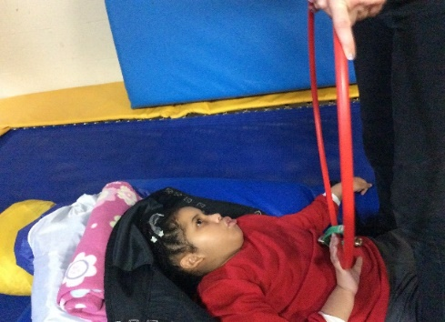
Attention and response (P2i)  Pupils begin to respond consistently to familiar people, events and objects. | Present different types of textured balls & light up effect balls to see if learner will reach out and pat when brought towards them | 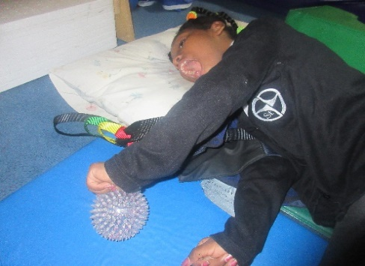
Engagement (P2ii)  Pupils begin to be proactive in their interactions by; | Roll a ball towards a learner to see if they push it away or off their lap | 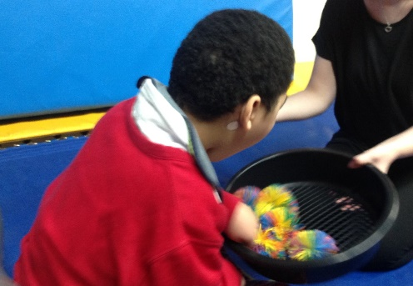
Engagement (P2ii)  Pupils begin to be proactive in their interactions | Present stimuli believed to be strongly liked or disliked and note the learner’s reactions. Do stimuli believed to be liked get different consistent reactions to those believed to be disliked? | 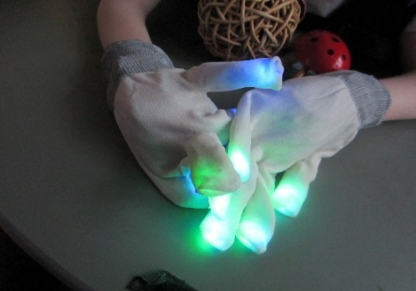
Participation (P3i)  Pupils begin to communicate intentionally | Use music warm up activities where the music stops and activity stops. Wait and see if learners may begin to anticipate when the music may start again. This can be through facial expression, gesture and vocalisation. | 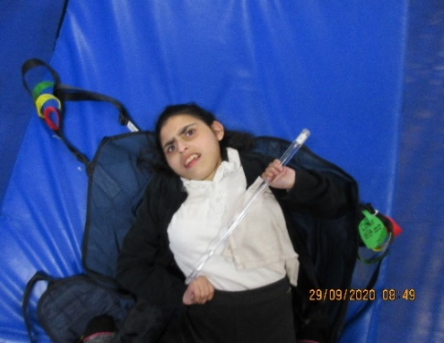
Participation (P3i)  Pupils begin to communicate intentionally | TacPac  Place the learner’s hand on an interesting object and assist to feel and pause. | 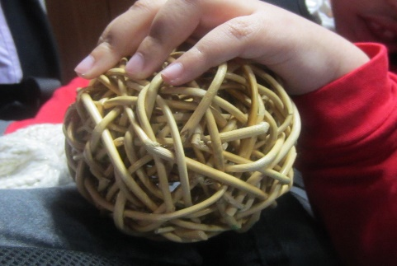
Engagement (P2ii)  Pupils begin to be proactive in their interactions | Art2Body  Present a range of stimuli, such as paint, foam does the learner show a different reaction when stimuli believed to be strongly liked or disliked is presented, and note the learner’s reactions. Do stimuli believed to be liked get different consistent reactions to those believed to be disliked? | 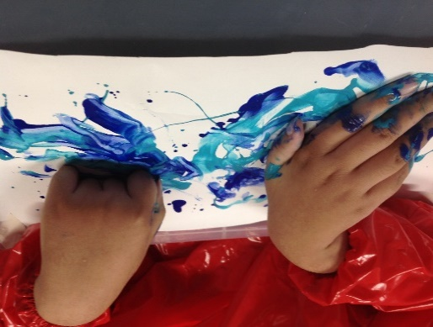
Involvement (P3ii)  Pupils use emerging conventional communication | Provide interesting visual/tactile experiences in a controlled way by regularly introducing new stimuli and drawing attention to them.  Observe reactions to a less familiar environment, when accompanied by a familiar adult. | 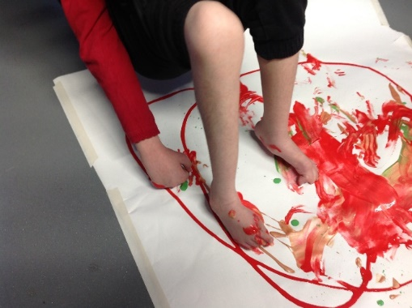
Involvement (P3ii)  Pupils use emerging conventional communication | Try a range of activities, which require the learner to interact repeatedly to gain an effect. Use a range of preferred objects or activities and use prompts to initiate exploration. Reduce these over time. Look for the learner deliberately making things happen in an everyday environment. | 